TMP-001

HOffice ProServ



Baseline Template for the Business

July 18, 2020 – Version 1.0

**- This Page Intentionally Left Blank -**

|  |  |  |  |
| --- | --- | --- | --- |
| **Document Name** | TMP-001: Business Requirements | | |
| **Responsible Executive** | CEO | **Responsible Department** | Information Security |
| **Point of Contact** | Lou Garcia |
| **Effective Date** | 07/18/2020 | **Revision Number** | 1.0 |
| **Revision Update Summary** | * Include key changes made to the document * Example: Added section Figures and Tables | | |

- This Page Intentionally Left Blank –

Contents

1. Introduction 1

1.1. Scope 1

1.2. Responsibilities 1

2. Template Styles 3

2.1. Headers 3

2.2. Lists 4

2.3. Tables and Figures 4

APPENDIX A: Appendix Header 1

A.1. Appendix Header 2 1

executive summary

When practical, an Executive Summary should be included to both summarize the intent of the document and to identify to the reader that the contents are supported by key stakeholders of the business. This section will serve to summarize the document so that the reader can easily digest the larger body of material without having to dissect its entirety. This section normally contains a brief statement of the problem (thus the reason for the document), or proposal covered, background information, concise analysis and conclusion.

Remember that an Executive Summary is written to serve as a miniature document that can be read in place of the larger document. It is often written along the same structure, yet no more than 10% in length, of the main body.

A “Section Break (Next Page)” separates the introductory portion of the document (i.e., authorization details, table of contents, and executive summary) from the main body of the message. In addition to separating page formatting styles, this also assists in separating the numbering scheme.

# Introduction

The introduction section is used to provide readers with general background, concepts, principles, and applicability information regarding the subject and content of the document. This section should include basic content that will help the reader consume, understand, and apply the information. Subtopics associated with this section includes Scope and Responsibilities.

## Scope

The purpose of the scope subsection is to outline the boundaries and applicability of the content of the document. This includes information such as identifying applicable regulatory requirements, activities, locations, business functions, and facilities. An example of a scope statement or paragraph includes: “<COMPANY> recognizes the need to comply with the National Institute of Standards and Technology (NIST) Core Cybersecurity Framework. The instructions provided in this document apply to all personnel and computing services in the organization with administrative management responsibilities delegated to the Information Technology department.”

## Responsibilities

The responsibilities subsection serves to specify and define key departments, offices, and personnel that are affected by or responsible for the execution of the components outlined in the document. Examples include:

* Chief Executive Officer (CEO): The CEO maintains overall strategic responsibility for the organization and is responsible for supporting the development, execution, communication, and enforcement of business policies.
* Steering Committee (SC): Chartered by senior directors and leveraged by subject matter experts and stakeholders, the SC assists in assessing, approving, developing, and prioritizing anything from projects to developing policies and governance procedures affecting business administrative, technical, and physical operations.
* Chief Security Officer (CSO) or Chief Information Security Officer (CISO): The CSO/CISO is responsible for the oversight and management of the business physical (e.g., facilities, media, safety, etc.) and digital (e.g., data and the tools used to secure digital identities, assets, and technologies) security posture.
* Chief Information Officer (CIO): The CIO is responsible for managing, implementing, and communicating information and computer technology resources, strategies, and policies of the business. They typically also make decisions regarding the purchase of IT equipment, vendors, and outsourced services.
* Chief Financial Officer (CFO): The CFO is the senior executive responsible for managing and planning financial activities of the organization.
* Information Technology (IT): The IT department is responsible for the deployment and day-to-day operations of electronic communications devices and services (i.e., functionality), hardware components (i.e., infrastructure), and overall digital well-being (i.e., governance) of the organization.
* Users: This applies to individuals and individual accounts that log into a computer or service. Note that users can range from general users to administrators and everything in between (e.g., database administrators, backup operators, etc.).

# Template Styles

When creating your template use fonts and colors approved by the organization. If these have not been identified, then work towards establishing them. Doing so helps to promote the brand and unifies business efforts. Fonts should be easy to read, convey professionalism, easily read at various sizes, and widely accepted to prevent distortion when read on various platforms and applications.

## Headers

The headers included in this template are suggestions and can be modified to meet business needs.

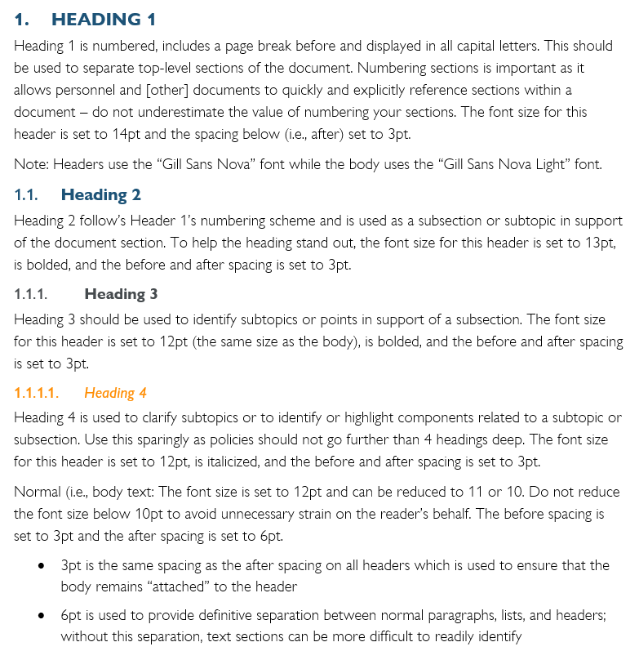

Figure 1: Header and Text Details

## Lists

When listing information in bullet format, use the “List Paragraph” style in the style bar. Bullets should be used to inform the reader of several items to either convince or provide evidence to support the previous topic. Numbering should be used when listing related items that require a particular order (most often found in checklists or procedures). The list format is formatted as follows:

* Indention is set at Left: 0.25”
* Hanging by 0.25” – “hanging” establishes where the following lines in the same bullet will line up; this lends to a more professional look and keeps the thought together
* Spacing:
  + Before: 3pt
  + After: 6pt
* Follow up indentions are set at 0.25” intervals

## Tables and Figures

Tables and figures should also be numbered to help the reader readily identify references. The captions in this template are set at 10pt font with a 3pt spacing before and 10pt spacing after the text to ensure that any follow up texts or figures have adequate spacing:

### Figure caption example

**FIGURE EXAMPLE**

Figure 2: Figure Caption Example

### Table caption example

|  |  |  |
| --- | --- | --- |
| Table | Header | Example |
| Table Body (Table-Normal) | 2pt space before | 2pt space after |
| Gill Sans Nova Light | 11pt font | Black |

Table 1: Table Caption Example

1. Appendix Header

The appendix header (APDX-1) is formatted similarly to the Header 1 style except for the first level numbering value which is set to A. It also includes a page break before, displayed in all capital letters, the font size for set to 14, and the spacing after set to 3 pt.

* 1. Appendix Header 2

Appendix header 2 (APDX-2) follow’s APDX-1’s numbering scheme. The font size for this header is set to 13, is bolded, and the before and after spacing is set to 3 pt.

* + 1. Appendix Header 3

Appendix header 3 (APDX-3) font size is set to 12 (the same size as the body), is bolded, and the before and after spacing is set to 3 pt.

* + - 1. Heading 4

Appendix header 4 (APDX-4) font size for this header is set to 12, is italicized, and the before and after spacing is set to 3 pt.

Note: to assist in numbering accurately, include a “Section Break (Next Page) after each appendix.